“The History of Warning Intelligence”

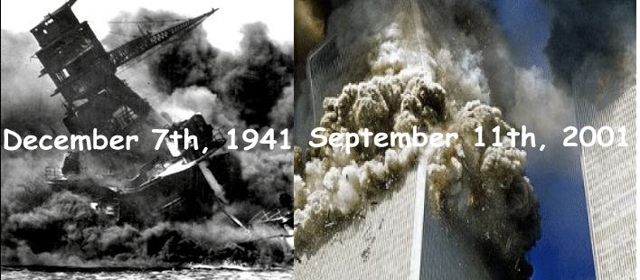
Syllabus

PWAD 360 - J.W. Caddell - Spring 20XX

History of Warning Intelligence (PWAD 360) -- This course describes the evolution of the warning mission and its role in shaping modern intelligence organizations. As part of this process, basic concepts associated with the warning mission are defined and discussed. The course focuses primarily on the American experience, but is not limited to it. Case studies from the ancient to the modern time periods provide examples for evaluation. There is a particular emphasis on the methodologies developed to improve warning and the problems inherent to the warning mission.

PWAD 360 J.W. Caddell
History of Warning Intelligence Spring 20XX

The contents of this syllabus are based on Faculty Council Resolution 2012-11, “Guidelines for Course Syllabi,” October 2012.
A syllabus, or course outline, defines the goals of a course and describes classroom activities, readings and other assignments, and course policies. Conventions for structuring a syllabus vary across disciplines, but what follows is intended to provide suggestions about what can be included. Syllabi are intended primarily as information for students, though sometimes colleagues and administrators also consult them for evidence of the instructor's expertise. A comprehensive syllabus can be a useful teaching tool. At a minimum, it should tell students
- Why learning this material might be important (course goals)
- What students will be learning (course content)
- When the material will be taught (schedule)
- How it will be taught (instructional procedures)
- When students will be required to demonstrate their learning (assignments and examination dates)
- How students' learning will be assessed (evaluation) and the final grade determined
If students cannot determine any of the information cited in Resolution 2012-11 from this syllabus, they should contact Caddell.

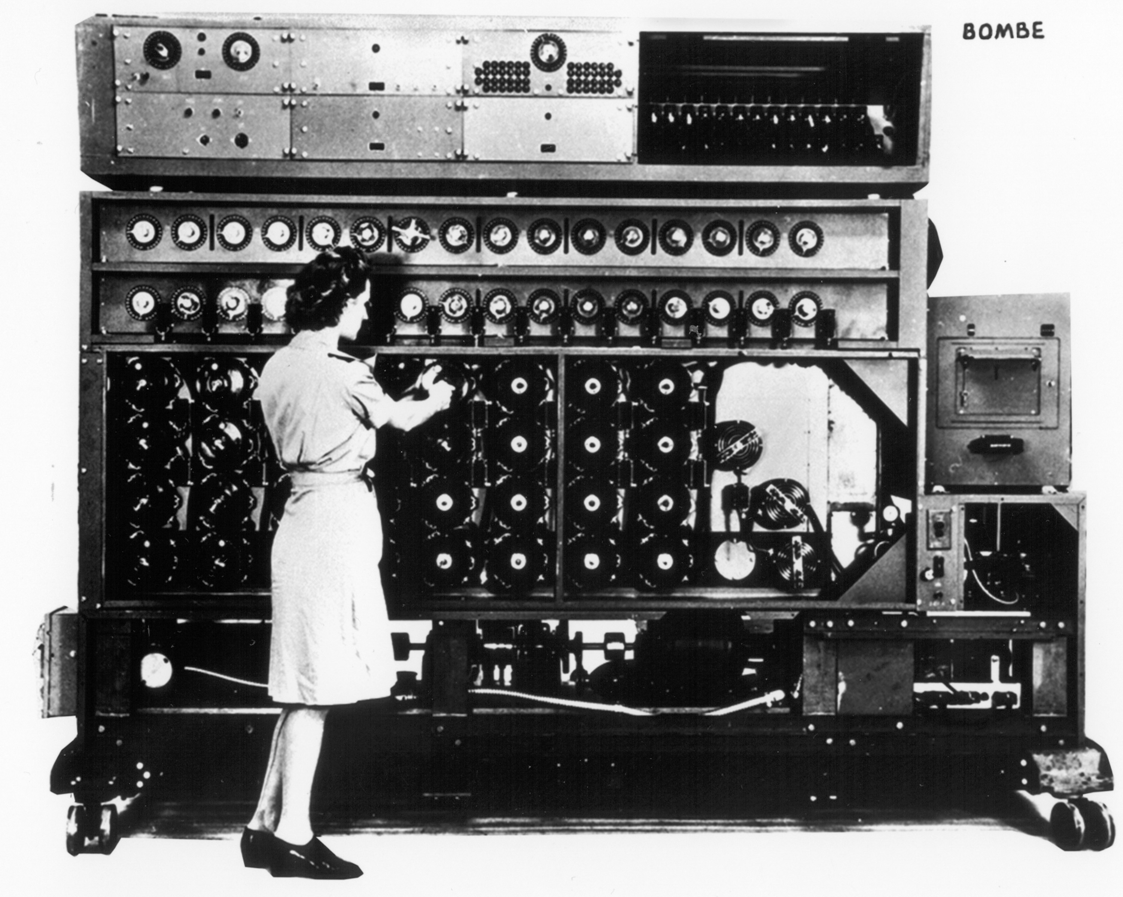
A “Bombe” – its purpose?

PWAD 360 J.W. Caddell
The History of Warning Intelligence Spring 20XX

Office Hours: 5-6 p.m. MW, 4-4:45 TTh, and by appointment (409 Hamilton)

Phone: 967-0471 Home (before 9 PM)

E-Mail: caddellj@email.unc.edu (Not my preferred method of communications.)

There is no SAKAI page for this course.

Texts: -Cynthia M. Grabo, Anticipating Surprise: Analysis for Strategic Warning
-Erik Dahl, Intelligence and Surprise Attack: Failure and Success from
Pearl Harbor to 9/11 and Beyond
-Gordon Prange, et al, Pearl Harbor: The Verdict of History
-Central Intelligence Agency, Strategic Warning & The Role of Intelligence
-Richard Betts, Surprise Attack: Lessons for Defense Planning
-National Commission on Terrorist Attacks, The 9/11 Commission Report:
Final Report of the National Commission on Terrorist Attacks Upon
the United States
- PWAD 360 Course Packet, UNC Student Stores

Assignments: % of Grade Due Date
Thesis Paper 15% 11 February
Mid-term Exam 15% 25 February-3 March
Dialectic Essay 25% 14 April
Final Examination 25% 6 May (4 p.m.)
Class Participation 20% Semester

Policy on Late Assignments: All late papers, excepting those involving certified excuses, will
receive a grade of “F”. Assignments not completed (late or otherwise) will receive a
grade of “O.” A single “O” will cause a student to fail the course; i.e. all assignments
must be completed to receive credit for the course.

Attendance: Your instructor does not desire the presence of any student who does not desire
to attend the lectures. However, students are responsible for all material covered
in the lectures and the identification sections of the examinations will be based
totally on material covered in the lectures.

Honor Code: It is expected that all students will be familiar with and abide by the standards of
The Honor Code of the University of North Carolina. All assignments will be signed by
each student attesting to compliance. If there are questions concerning compliance, the
instructor or the teaching assistant will be glad to answer them.

Alpha-Numeric Grade Correlations: This course will utilize a 10 point grade scale.
A = 95-100 B = 83-86 C = 73-76 D = 63-66
A- = 90-94 B- = 80-82 C- = 70-72 D- = 60-62
B+ = 87-89 C+ = 77-79 D+ = 67-69 F < 60
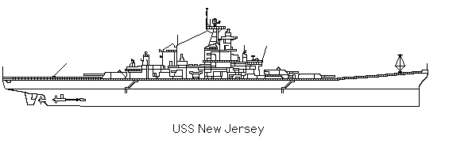
Course Schedule

Dates Topic Readings

12-19 January 20XX Warning and a Discussion of Concepts B 1-3, D 1, G All.

21-26 January Warning in the Pre-Modern World B 1-3, D 1, G All

28 Jan – 2 February Warning in “Industrial” World (to 1918) B 1-3

4-9 February Second World War in Europe B 5-7

*11 February The Rise of SIGINT (MH) TBD (Handout)

16 February Pearl Harbor B 8, D 2, P All

18 February Second World War in the Pacific D 3-4

23-25 February Korea, 1950 B 17-18

*1-3 March The Cold War B 9-15 & 22

8-10 March Arab-Israeli Wars B 19-21

22 March Vietnam B 17

24-31 March Nuclear Balance B 16&25

5-7 April The “Other” (Terrorism, etc.) B 23-24, D 5-6

*12-14 April 9-11 N All, D 7-8

19-21 April Summary of “Lessons” B 23-25

26 April Policy Implications B 23-25

*6 May (4 pm) Final Examination All
__________________________
*Denotes a segment when assignment is due
Note: Under the "Readings" column, B = Betts; C = CIA, D = Dahl; G = Grabo, N = National Commission on Terrorist Attacks Upon the United States, and P = Prange

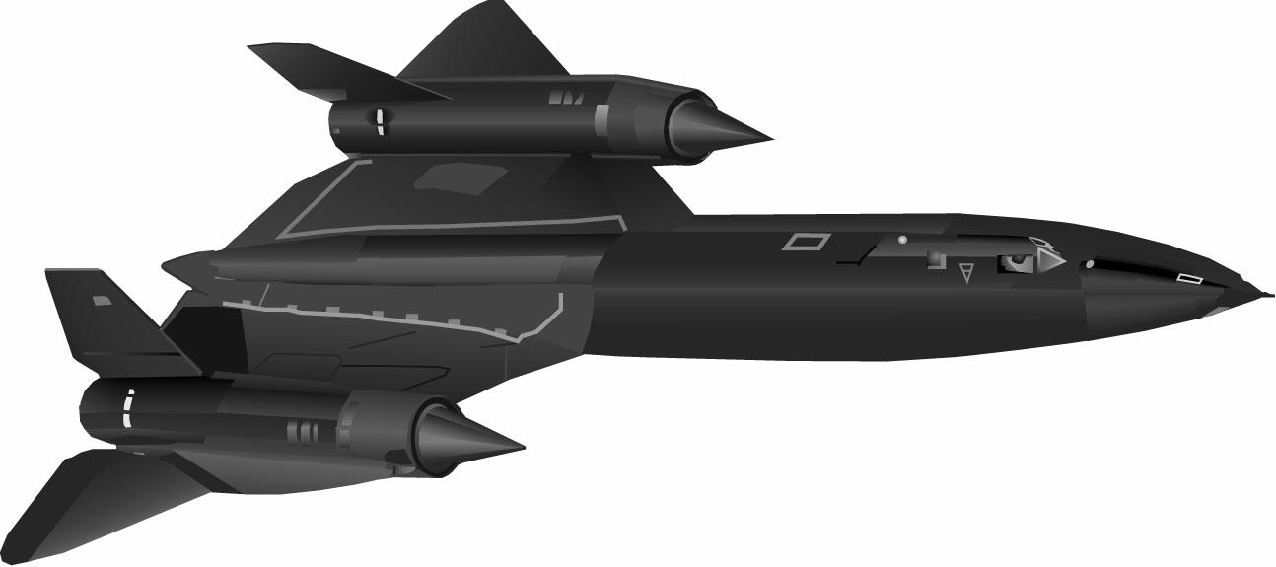

Course Objectives

The objectives of an academic course can range from the very general to the incredibly specific. Should a student care? Is this too limiting?

Why we have “DLO’s” in this course. The “DLO’s” in this course:

1. To develop and to improve fundamental powers of logic. This includes honing your ability to analyze and to synthesize information. The critical assessment of historical interpretations, as well as the students’ abilities to develop their own interpretations and arguments will be stressed.

2. To strengthen verbal capabilities, both oral and written. This will be accomplished through the writing of formal papers, essay examinations, and class discussions.

3. To become familiar with some basic concepts, events, and institutions that have evolved through the evolution of the warning intelligence mission. This will involve the learning of some “stuff.” To quote the Faber College motto, “Knowledge is good.”

4. To develop a sense of “historical difference.” This entails coming to appreciate the fact that the passage of time causes change and that this change is ongoing. We will discuss Mark Twain’s observation that “While history does not repeat itself, it may rhyme.”

5. To become aware of the debates -- or dialectics -- inherent to the evolution of the warning intelligence function. These include questions relating to the problems intrinsic to the warning mission. We are especially interested in identifying the objectives of the American intelligence community. In the process, we must recognize and discuss the problems and dangers inherent to the warning mission.

6. To appreciate the role of warning intelligence in the American context. This includes an understanding of the history of American intelligence organizations, but also leads us to examine intelligence organizations and events outside of the American context.

7. To have fun. As history is the story of people doing “stuff,” it is the story of smart people, dumb people, nice people, mean people, normal people, and perverse people.

What this course is not:

- An attempt to create professional intelligence officers.
- An attempt to recruit anyone for anybody.
- A training program for true/false, multiple guess, or rote
memory examinations.
- An arena for the promulgation of political ideology. All
opinions supported by evidence and logic are welcome.

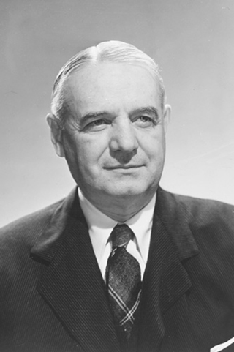
William Joseph "Wild Bill" Donovan
(1883 – 1959)
A NOTE ON THE GRADING OF HISTORY PAPERS

A major goal in any history course is that the students think critically and improve their ability to organize and to communicate their ideas. As a result, your paper assignments will be evaluated as to how effectively you have demonstrated these abilities.
The framework for this evaluation will be structured around “DOLPS”
This acronym stands for:
D = Data
O = Organization
L = Logic
P = Prose
S = Scope

These areas may be further explained as follows:

Data: The evidence you use to support your points.
Is it sufficient? Is it clear? Is it accurate?
Is it cited?
Organization: The structure of your thoughts and sentences.
(Yes, there is a connection). Do you follow a logical sequence? Do you have an introduction?
Do you have a conclusion?
Logic: The reasoning you utilize. Is it clear?
Does it follow a rational sequence?
Prose: Your writing ability. This includes the
“mechanics” of spelling and grammar, as well
as your overall style.
Scope: The extent to which your paper covers the
assignment. Is it broad enough? Does it go
into sufficient depth? Is it clearly focused?

Clearly, these are not mutually exclusive terms. There is considerable overlap. Organization relates to logic, to scope, and is, in turn, affected by prose. Think of your paper as a tool of communication and the logic behind this system should become clear. Remember, if you have questions, see the professor!

Good Luck,
Caddell

“I love to write, I just can’t seem to get anything on paper.”
-PWAD 350 student, 1999

“Why should you grade my writing? This is a history class!”
-Former History 212 student, 2005 (currently
employed at the Burger King in Sanford)
Assignments

Thesis Paper 11 February
Mid-term Exam 25 February - 3 March
Dialectic Essay 14 April
Final Examination 6 May (4 PM)

Detailed instructions for the assignments are provided on the following pages.

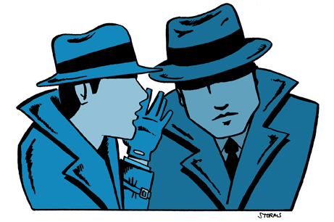

WRITING A THESIS PAPER
(Due 11 February 20XX)

A “thesis” is an argument, assertion, or statement requiring evidence and proof in order to gain acceptance. It is a claim which must be proven and defended. It is not self-evident. It consists of a statement (the thesis statement) supported by appropriate evidence, organized in a logical manner, presented in a convincing style. The thesis statement can usually be summarized in one sentence. This statement provides an answer to a question. All theses are answers to questions. These questions may be explicit or implicit.
A thesis paper should be structured as a self-contained argument, containing, in written form, the evidence and logic necessary to prove a specific thesis. Such a paper is usually introduced through the presentation of the inherent question. For example, a thesis arguing that “The United States was perfectly justified in dropping an atomic bomb on Hiroshima, Japan” is answering the question of “Was the United States justified in the atomic bombing of Hiroshima?” Stating the question and explaining its significance is a reasonable method for beginning the paper. The thesis (answer) may be revealed at this point or the writer may wait to reveal the thesis as part of the paper’s conclusion. Either technique may be desirable. It is a matter of style.
The introduction should, therefore: 1) introduce the subject, usually via a historical question, 2) perhaps present your answer/thesis, 3) explain the significance of the topic, and 4) tell the reader what sorts of points and evidence will be used to conduct your presentation. If you have already “given away” your thesis, you can be fairly specific in outlining the points you will make in arguing your thesis.
The main body of the paper should be a construction of the major points which you have outlined in the introduction. They should be well supported by evidence, logically argued, and clearly stated. Reviewed in their entirety, they should make your thesis appear obvious and reasonable.
Finally, your conclusion should restate the historical question and briefly review your points, evidence, and logic. Finally, clearly express your thesis in no more than one sentence; and leave the reader convinced of your argument.

Details to Remember
--The paper must be typed, double-spaced.
--Citations must be used to cite every quote, fact,
or idea taken from a source other than your own brilliance
--Include a bibliography page.
--The recommended length is five (5) pages. Use common sense.
--Make sure that you have a “thesis” rather than a mere topic.
--ALL INTERNET SITES MUST BE VETTED
--If in doubt, see me!

SAMPLE THESIS PAPER OUTLINE

(This outline is not required. It is merely an example of one way to organize a thesis. Hopefully, it provides a basic and concise structure.)

- INTRODUCTION

--¶ General overview of the subject: What, when, who, where, etc.?

--¶ Explain the disagreement: What is the question? Who says what?

--¶ What will be proven in this essay? This is the thesis. Briefly outline
the points which will be used to prove this thesis? (“Sign Posts”)

II. POINTS

-- ¶

--¶

--¶

--¶

III. CONCLUSION

-- ¶ Summarize II (the main points).

--¶ Note quality of the evidence and logic.

--¶ Restate thesis.

BIBLIOGRAPHY: A bibliography is not the same as a works cited page. It should include all of the sources you used, whether you cited them or not. “Vetting” requires a short paragraph ascertaining the credibility and objectivity of the source cited – this is REQUIRED FOR ALL INTERNET SITES. This is NOT accomplished by simply asserting “This was a credible source.”

DIALECTIC ESSAY
(Due on 14 April 20XX)

Dialectic: [ME Dialetic, fr. MF dialetique, fr. L dialectica, fr. G dialektike, fr. fem. of dialektikos of conversation, fr. Dialektos]...development through the stages of thesis, antithesis, and synthesis...any systematic reasoning, exposition, or argument....that juxtaposes opposed or contradictory ideas and usually seeks to resolve their conflict. (Webster’s Seventh New Collegiate Dictionary Springfield, Mass.: C. & C. Merriam Co., 1963, p. 229)

The dialectic essay is a basic and vital assignment. Your goal is to review, in an objective fashion, two interpretations of a single historical topic. You will, in effect, present two sides of an argument. This is accomplished by identifying a significant historical question and explaining two, mutually exclusive, historical theses, each of which represents an attempt to answer the central question. Do not be intimidated by the title (multi-syllabic) or length (approximately 10 pages) of this assignment. It is a simple paper to organize and, once your purpose is understood, a relatively minor drain upon your valuable time.
The first order of business is to explain the significance of your topic and to introduce the reader to the nature of your historical question. It is strongly recommended that you state the historical question, rather than merely imply it. State your question clearly and precisely. Do not leave the reader to work this out by inference. The reader may make a mistake, but you will receive the grade.
It is also recommended that you use the introduction to describe briefly the two interpretations (theses) your paper will cover. This prepares the reader for the two perspectives to be evaluated and begins to define the scope of your effort. From this point you are ready to summarize the first thesis or interpretation.
The first side’s interpretation should be explained in a clear and organized format. Their thesis should be summarized in a single sentence and the basic points should be summarized in separate, sequential, paragraphs. Do the same for the second side of the argument – the antithesis. Make it explicitly clear that these are NOT your arguments. In combination, the summaries of the two sides will constitute more than half of the essay.
Next, evaluate the two sides. Tell the reader whether or not the points (arguments) were supported by evidence. Describe and evaluate the research conducted by each side. What were their sources? Evaluate the logic of each. Do the evidence and the logic, in combination, prove the overall thesis? Repeat this process for the other side of the argument (the other thesis).
After you have evaluated both sides of the dialectic, you are ready to summarize and to synthesize the two interpretations. Briefly review the points contained within the two interpretations. Evaluate them. Assess their proof – judge their evidence and logic. Be fair, but critical. Objectivity is vital, but you may find that one side possesses a stronger case. The important thing is to be able to explain why this appears to be so. As long as you can cite specific differences in the quality of evidence and logic, you are on firm ground.
Admittedly, your evaluation will be subjective. All evaluation is based upon value judgments. At the same time, however, it is crucial that you explain your assessment in a manner which can be understood and appreciated by others. To achieve this end, logic and reference to specific information are vital.
The final result of your evaluation will be your own answer to the historical question. This will be your thesis and, because it will arise out of an evaluation of the two previous theses, it will be a synthesis. It may agree totally with one of the original theses or it may be a blend of the two. Support this interpretation with specific points, combined in a logical sequence, to prove your thesis. Be concise, clear, and generally brilliant. Your thesis is your conclusion.

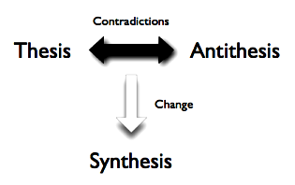

DIALECTIC OUTLINE

(As with the thesis, this outline is not required. However, because a “dialectic” must follow the process of hypothesis, antithesis, and synthesis, the basic components of this outline need to be included in the overall structure of your paper.)

I. Introduction.

--¶ Introduce the general subject. Explain its significance.
--¶ Identify the historical question and briefly outline the various interpretations that
comprise the dialectic.
--¶ Briefly explain what this paper will do. Explain the concept of the dialectic.

II. Explain the first thesis. [Make it explicitly clear that this is someone else’s argument.]

--¶ Identify the author(s). Provide background information. Such as?
--¶ Explain the author's thesis.
-- Multiple ¶: Explain the author’s or authors’ points/arguments. (One
paragraph per point)

III. Explain the second thesis. [Make it explicitly clear that this is someone else’s argument.]

--¶ Identify the author(s). Provide background information.
--¶ Identify the thesis argued by this side.
-- Multiple ¶: Explain the author’s or authors’ points/arguments. (One
paragraph per point)

IV. Evaluate the two theses.

--¶x2 Evaluate their evidence – be specific and detailed regarding their
research. This is a minimum of two paragraphs – one for each side.
--¶x2 Assess their logic. This is a minimum of two paragraphs – one for
each side.
--¶ Compare and contrast the relative “worth” of each thesis.

V. Conclusion.

--¶ Summarize the two theses.
--¶ Review the evaluation of both sides. Note the strongest points made in
the two interpretations.
--¶ Present a synthesis. Explain and defend this thesis.

BIBLIOGRAPHY: A bibliography is not the same as a works cited page. It should include all of the sources you used, whether you cited them or not. “Vetting” requires a short paragraph ascertaining the credibility and objectivity of the source cited – this is REQUIRED FOR ALL INTERNET SITES.
Examinations
(25 February- 3 March and 6 May 20XX)

The purpose of the midterm and final examinations is to encourage the synthesis of information covered in the course. You are expected to synthesize material on a variety of subjects, from a variety of perspectives, out of a number of sources. Hopefully, knowing the purpose of these assignments will be helpful in preparing for them.
The essays should be organized, supported by relevant evidence, and constructed around a central thesis. The logic should be explicit and clear. On the midterm the essays will be “take home” assignments. You will receive the essay topics on 25 February and have a week to write your paper. The final examination will be conducted entirely “in class,” but a list of potential essay topics will be provided the last day of class. On each exam the essays will be worth 60% of the grade.
Each exam will have an “in class” section of “identifications” which will be worth 40% of the grade. The midterm identifications will be written in class on 3 March – the day you turn in the “take home” essay. On both exams these will be people, places, events, objects, and ideas. You will be asked to identify them and to explain their significance. A useful checklist for answering these “identifications” would include: “who, what, where, when, and so what?”

A brief synopsis of common problems noticed on recent examinations:

- Failure to use paragraphs for organization
- Essays which are less than comprehensive
- Long essays which fail to focus on the question being asked
- Essays which lack a summary conclusion
- Identifications which fail to cover the “who, what, where, when,
and so what?”

